JavaScript Runtime & Execution
JavaScript is often called a "single-threaded, non-blocking, asynchronous, concurrent" language.
That sounds like a massive contradiction—how can something be single-threaded and concurrent?
The Architecture of the JavaScript Runtime
Think of the runtime as a bustling factory. The JavaScript Engine is the main worker, but the Runtime provides the conveyor belts, assistant workers, and storage rooms.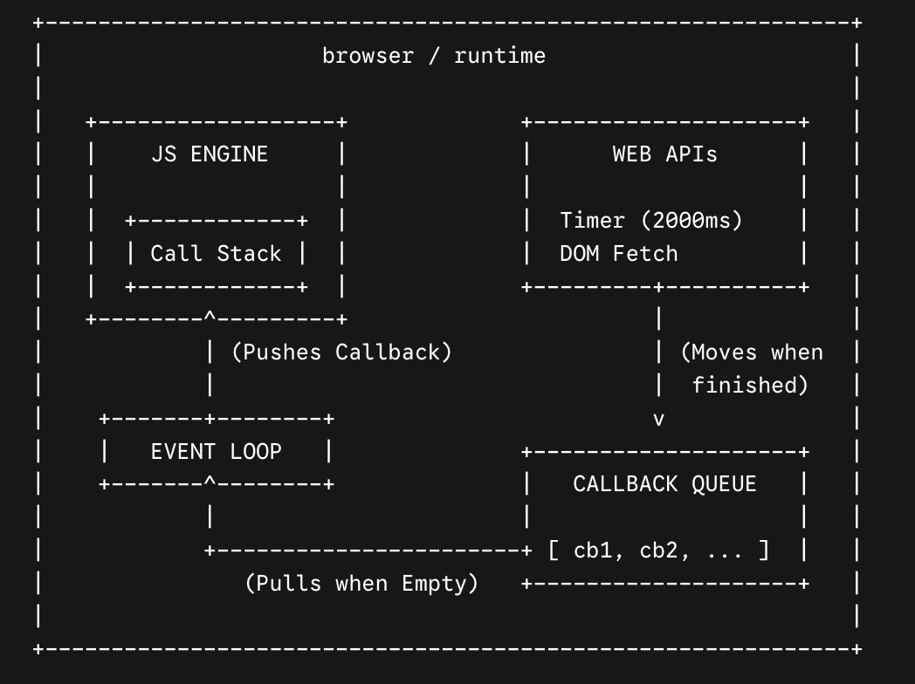

A. The JavaScript Engine (e.g., V8 in Chrome/Node.js)
The engine's job is to read and execute your code. It consists of two main parts:
- The Memory Heap: A large, mostly unstructured region of memory where the engine stores objects, variables, and functions you define.
- The Call Stack: A LIFO (Last In, First Out) data structure that tracks where we are in the program. Whatever function is at the top of the stack is what the engine is currently executing.

B. Web APIs (or C++ APIs in Node.js)
Because the engine has only one Call Stack, it can only do one thing at a time. If you ask it to wait 5 seconds, it would freeze your whole browser. To prevent this, browsers give us Web APIs. These are external threads handles by the browser, not the JS engine. They include:
- setTimeout() and setInterval()
- DOM Events (clicks, scrolls, keypresses)
- Fetch / XMLHttpRequest (network requests)

C. The Callback Queue (Task Queue)
When a Web API finishes its job (e.g., a timer expires or a network request returns data), it doesn't just shove its callback function straight into the Call Stack—that would disrupt running code. Instead, it places the callback into the Callback Queue, waiting for its turn.

D. The Microtask Queue
A special, high-priority queue specifically for Promises (.then(), .catch(), async/await) and MutationObserver. It always cuts in front of the regular Callback Queue.

E. The Event Loop
The referee of the whole system. The Event Loop has one simple job: it constantly looks at the Call Stack and the Queues.
The Golden Rule: If the Call Stack is completely empty, the Event Loop takes the first task from the Microtask Queue (or Callback Queue if microtasks are empty) and pushes it onto the Call Stack to be executed.

A Complete Code Example & Step-by-Step Execution
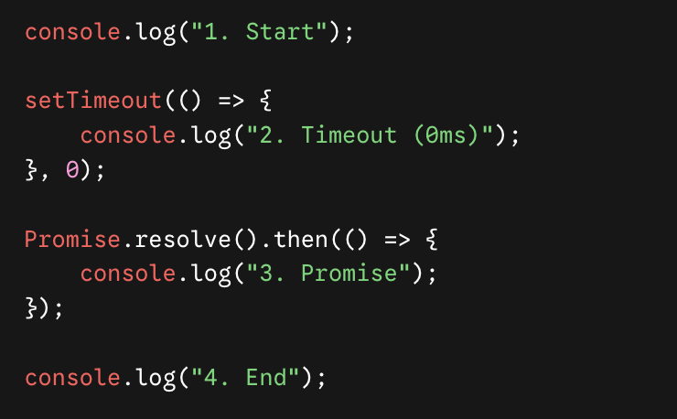

The Output:
If you run this, the output will always be:
- 1. Start
- 4. End
- 3. Promise
- 2. Timeout (0ms)

Why? Step-by-Step Execution Tracking:
- console.log("1. Start") enters the Call Stack. It prints to the console immediately and pops off the stack.
- setTimeout(..., 0) enters the Call Stack.
  - The JS engine recognizes this is a Web API. It hands the timer over to the browser and pops setTimeout off the stack.
  - The browser starts a 0ms timer. Because it's 0ms, it finishes instantly and moves the inner callback function () => { console.log("2...") } into the Callback Queue.
- Promise.resolve().then(...) enters the Call Stack.
  - The engine recognizes this is a Promise. The callback () => { console.log("3...") } is immediately sent to the Microtask Queue. The Promise pops off the stack.
- console.log("4. End") enters the Call Stack. It prints to the console immediately and pops off the stack.
- The Call Stack is now EMPTY.
- The Event Loop wakes up and checks the queues. It looks at the Microtask Queue first.
  - It finds the Promise callback. It pushes it onto the Call Stack.
  - 3. Promise is printed. The Call Stack is empty again.
- The Event Loop checks the Microtask Queue again (it's empty), so it checks the Callback Queue.
  - It finds the setTimeout callback. It pushes it onto the Call Stack.
  - 2. Timeout (0ms) is printed.
This is why a 0ms timeout doesn't mean "run immediately"—it means "run as soon as the stack is clear and all microtasks are done!"

Asynchronous Evolution

The Three Eras of JavaScript Async
Era | Syntax Pattern | The Main Problem It Solved | The New Problem It Created
1. The Past | Callbacks | Allowed code to run non-blocking after a task finished. | "Callback Hell" and unreadable nested code.
2. The Transition | Promises | Escaped nesting by using flat, chainable .then() blocks. | Still required heavy boilerplate and verbose chaining.
3. The Present | Async / Await | Made async code look and behave exactly like synchronous code. | Requires understanding Promises under the hood; easy to accidentally run things sequentially.

1. The Callbacks Era (The Foundation)
In the early days, if you wanted to perform an action after an asynchronous task finished, you passed a function as an argument to another function. This passed-in function is a callback.
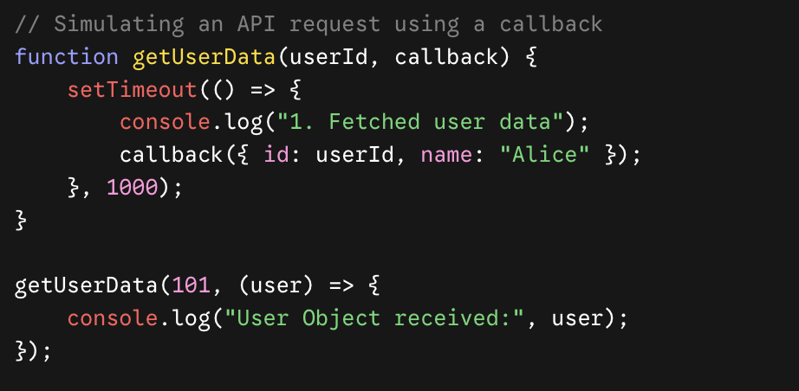

The Downside: "Callback Hell" (The Pyramid of Doom)
Callbacks work fine for a single operation. But what if you need to fetch a user, then fetch their orders, then fetch the shipping details for those orders, and then generate an invoice?
You end up with deeply nested code that crawls horizontally across your screen:
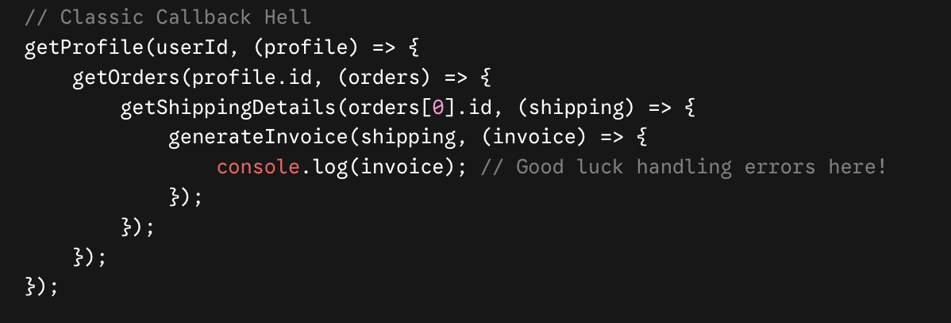

2. The Promises Era (ES6 / 2015)
To rescue developers from Callback Hell, ES6 introduced Promises. A Promise is an object representing the eventual completion (or failure) of an asynchronous operation.
A Promise exists in one of three states:
- Pending: The operation is still working.
- Fulfilled: The operation completed successfully (.then() triggers).
- Rejected: The operation failed with an error (.catch() triggers).
Here is how the nested callback chain looks when refactored into a clean, flat Promise chain:
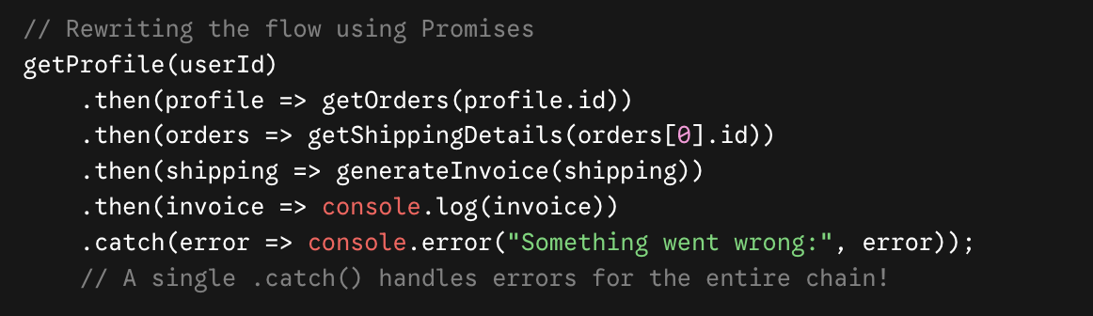
While Promises drastically improved readability and error handling, writing long .then() chains with multiple anonymous return functions could still become verbose and difficult to debug.

3. The Async / Await Era (ES8 / 2017)
The ultimate evolution of asynchronous JavaScript is async/await. It is built completely on top of Promises, acting as "syntactic sugar." It doesn't change how JavaScript runs under the hood; it just makes asynchronous code look like clean, readable, synchronous code.
- async: Placed before a function to indicate it will return a Promise.
- await: Placed before a Promise. It pauses the execution of the async function until the Promise resolves or rejects.
Here is the exact same sequential workflow written in modern async/await:
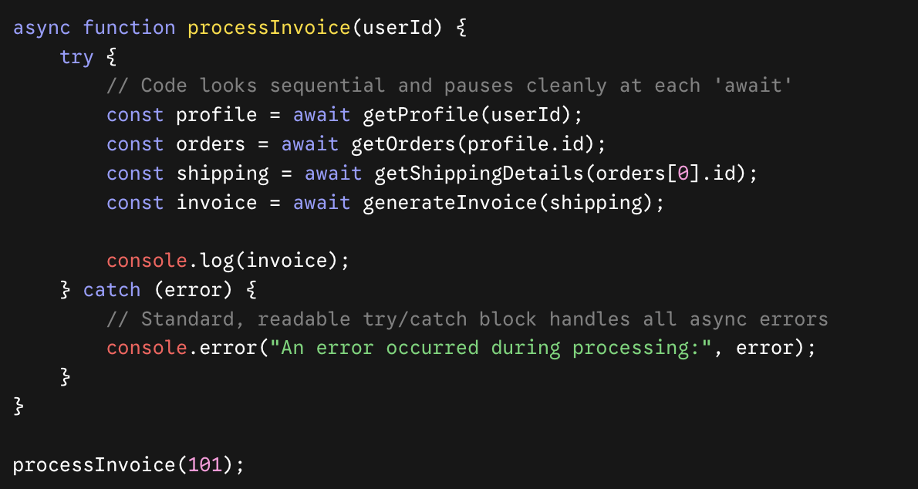

The Event Loop Connection
Remember: await does not block the entire browser thread. When the runtime hits an await, it pauses only that specific function, steps out of it, continues running other scripts on your page, and puts the paused function into the Microtask Queue to resume as soon as the awaited Promise finishes.

Scopes, Closures, and Lexical Environments

1. Scope & The Scope Chain (The Boundary)
While Lexical Environment is the mechanism, Scope is the rule. Scope defines the accessibility and visibility of variables in different parts of your code.
JavaScript has three main types of scope:
- Global Scope: Variables declared outside any function or block. Accessible from anywhere.
- Function Scope: Variables declared inside a function. They cannot be accessed outside that function.
- Block Scope (ES6): Variables declared with let or const inside a block { } (like an if statement or a for loop). They are restricted entirely to that block.

The Scope Chain
When you try to access a variable, JavaScript will first look inside the current scope. If it can't find it, it travels up the Scope Chain (using those outer lexical references) until it finds it or reaches the global scope. If it reaches the global scope and still can't find it, it throws a ReferenceError.

2. Closures (The Magic Connection)
A Closure happens when a function is defined inside another function, and the inner function remembers and retains access to its outer lexical environment, even after the outer function has finished executing.
In many programming languages, when a function finishes running, its local variables are wiped from memory (garbage collected). In JavaScript, if an inner function is still accessible somewhere (e.g., it was returned or assigned to a global variable), the engine keeps the outer function's Lexical Environment alive in memory.

Code Example: The Counter
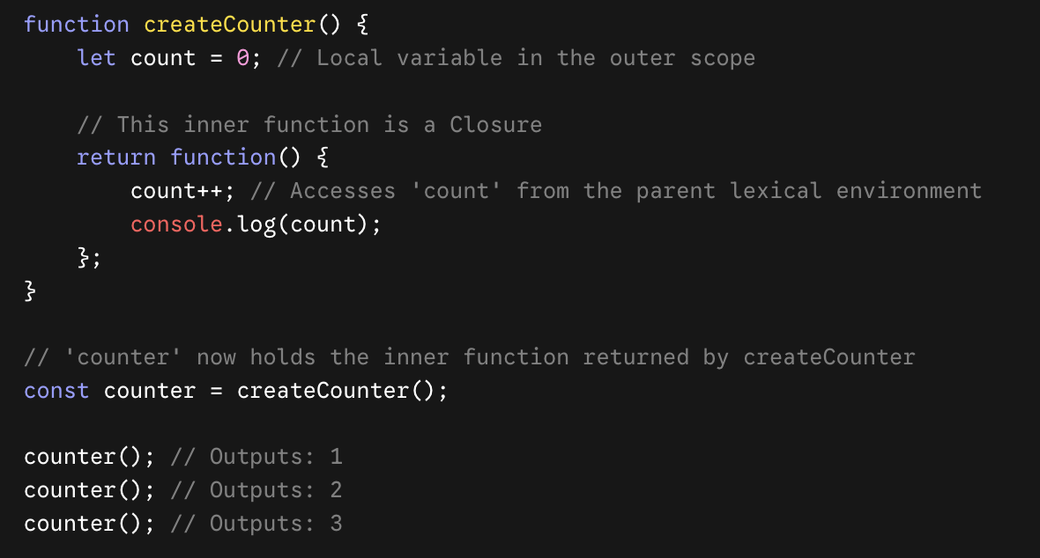

What just happened?
- We invoked createCounter(), which created a Lexical Environment where count = 0.
- createCounter() returned the inner anonymous function and popped off the Execution Call Stack. Its execution is completely over.
- Normally, count should be deleted. But because the returned function references count, a Closure is formed. The inner function preserves a backstage pass to createCounter's Lexical Environment.
- Every time we call counter(), it modifies that same preserved count variable.

Homework:
Learn how inheritance is performed in Javascript.

Hoisting & Variables
Hoisting is JavaScript's default behavior of moving declarations to the top of their containing scope (either the global scope or the current function scope) during the Memory Creation Phase before the code is actually executed.
It is crucial to understand that JavaScript only hoists declarations, not initializations (assignments).

How the JavaScript Engine Sees Your Code
When you run a piece of JavaScript code, the engine splits execution into two phases:
- Memory Allocation Phase: It scans the code for variable and function declarations and sets aside memory for them.
- Execution Phase: It executes the code line-by-line, assigning values and running functions.
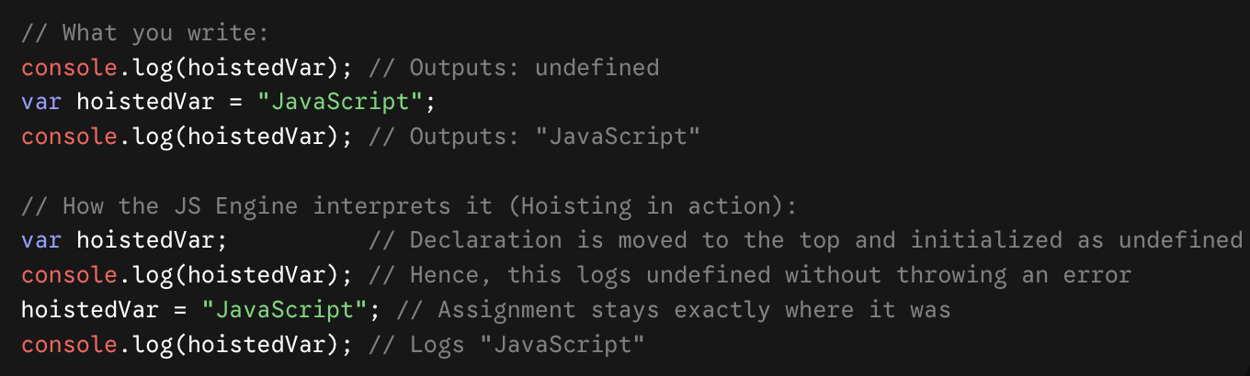

Variable Declarations: var vs let vs const
While all variables in JavaScript are technically hoisted, how they behave during hoisting depends entirely on the keyword used to declare them.

1. The var Keyword
- Scope: Function-scoped. If declared outside a function, it becomes globally scoped and attaches itself to the global window object. It completely ignores block scopes (like if statements or for loops).
- Hoisting: Hoisted to the top of its scope and automatically initialized with a value of undefined.
- Re-declaration: You can freely re-declare and re-assign var variables within the same scope without errors.
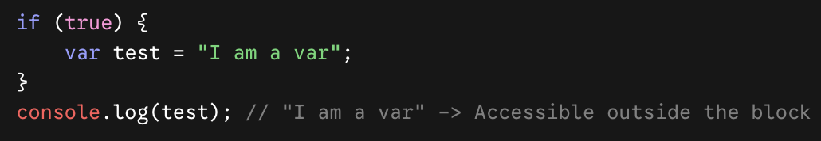

2. The let Keyword
- Scope: Block-scoped. A block is anything wrapped in curly braces {}. It is only accessible within that specific block.
- Hoisting: Hoisted to the top of its block, but not initialized. It is placed in a state called the Temporal Dead Zone (TDZ).
- Re-declaration: Cannot be re-declared within the same scope, but can be re-assigned.

3. The const Keyword
- Scope: Block-scoped (just like let).
- Hoisting: Hoisted to the top of its block, but not initialized (also stays in the Temporal Dead Zone).
- Re-declaration & Assignment: Strict limits. It must be initialized at the time of declaration, and it cannot be re-assigned or re-declared.
⚠️ Important Caveat: While you cannot re-assign a const primitive value, const objects and arrays are mutable. You can change their internal properties or elements, you just cannot assign a completely new object or array to that variable name.
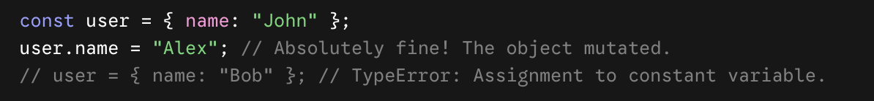

What is the Temporal Dead Zone (TDZ)?
The TDZ is the period of time/area of code from the start of the block scope until the moment the JavaScript engine completely processes the let or const declaration line.
If you try to access a let or const variable inside this zone, JavaScript will throw a strict ReferenceError. This is a safety feature designed to prevent bugs caused by using variables before they have been properly set up.

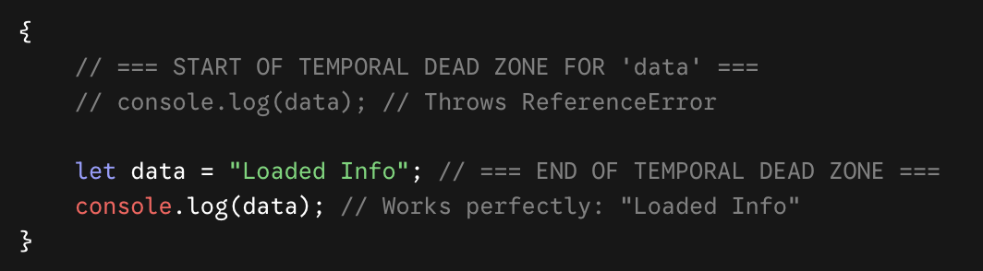

Map, Filter & Reduce

1. Array.prototype.map()
The map() method creates a brand new array populated with the results of calling a provided function on every single element in the calling array.
- Use case: When you need to transform every item in an array 1-to-1 (e.g., doubling numbers, converting strings to uppercase, extracting specific object properties).
- Array Length: The output array is always exactly the same length as the input array.
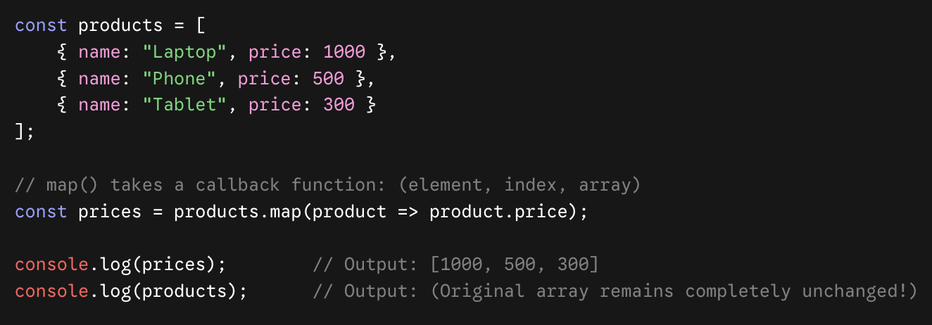

2. Array.prototype.filter()
The filter() method creates a shallow copy of a portion of a given array, filtered down to just the elements from the given array that pass a specific test (implemented by the provided callback function).
- Use case: When you want to select a subset of items based on a condition (e.g., getting only even numbers, finding active users).
- The Callback Rule: Your callback function must return a boolean value: true to keep the item, or false to discard it.
- Array Length: The output array can be shorter than or equal to the original array length.
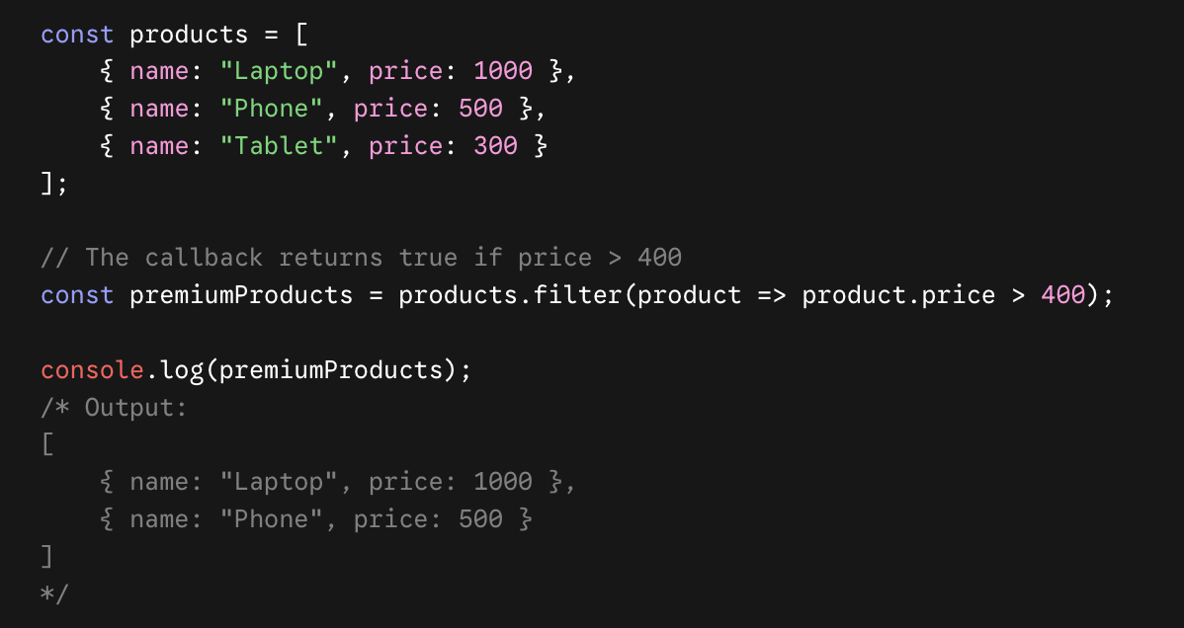

3. Array.prototype.reduce()
The reduce() method executes a user-supplied "reducer" callback function on each element of the array, passing in the return value from the calculation on the preceding element. The final result of running the reducer across all elements of the array is a single value.
- Use case: When you need to aggregate an array into one final output (e.g., summing up numbers, tallying item frequencies, flattening arrays, compounding an object).
- Key Components: It accepts two arguments: the callback function and an Initial Value (highly recommended to always provide this!).
The callback function takes four arguments, but the first two are the most critical:
- accumulator: The accumulated value rolled over from the last loop's return statement.
- currentValue: The current item being processed in the loop.

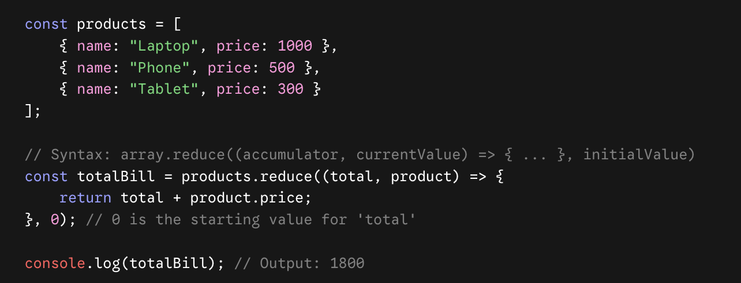

Ultimate Example: Find the total value of premium products only
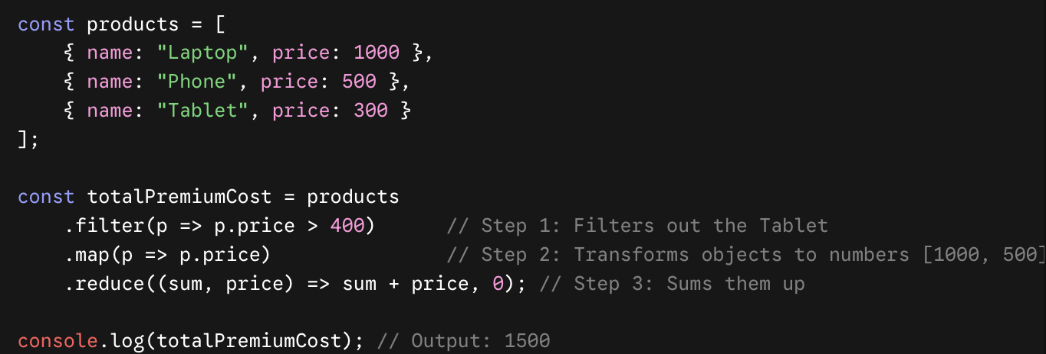
Questions:
- https://www.hackerrank.com/challenges/js10-create-a-button/problem?isFullScreen=true&hr_b=1
- https://www.hackerrank.com/challenges/js10-buttons-container/problem?isFullScreen=true&hr_b=1

